Micro Goal
Ideation Phase
Brainstorm & Idea Prioritization
Date | 16 feb 2026
Team ID | SWTID-2026-7531
Project Name | MicroGoal
Maximum Marks | 4 Marks

Brainstorm & Idea Prioritization Template
Step-1: Team Gathering, Collaboration and Select the Problem Statement:-
Team gathering is the first step of the project. In this step, students form a small team to work together on a project. Each member in the team may have different skills, ideas, and knowledge. When they work together, they can solve problems more effectively.


Step-2: Brainstorm, Idea Listing and Grouping:-
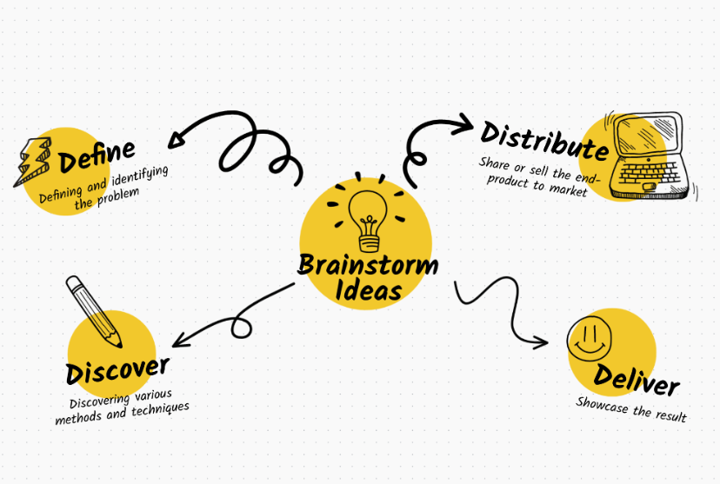

Step-3: Idea Prioritization:-
Idea Prioritization is the process of selecting the best idea from many generated ideas. After brainstorming, the team may have several possible solutions.
